New Part [**BBa_K3981013**](http://parts.igem.org/Part:BBa_K3981013): 请放置这个PART的main page 页面

Based on the result that Her2-ISZ-sTRAIL protein could efficiently inhibit the growth of breast cancer cells, in order to enhance the anti-tumor effect of Her2-ISZ-sTRAIL protein, E.coli Nissle 1917 (EcN 1917), an intestinal probiotic with higher tumor-targeting ability to proliferate in hypoxic regions of tumors, was utilized as a targeted transport vector to deliver Her2-ISZ-sTRAIL protein to tumor hypoxic regions. Therefore, a new part ([**BBa_K3981013**](http://parts.igem.org/Part:BBa_K3981013)) of pET28a(+)-Vgb-pelB-linker-His-linker-Her2-linker-ISZ-Strail (Vgb-pelB-Her2-ISZ-sTRAIL for short) was constructed, in which Her2-linker-ISZ-Strail was placed under the hypoxia promoter Vgb and signal peptide pelB was added to increase the secretory expression of Her2-linker-ISZ-Strail protein (Fig. 1).

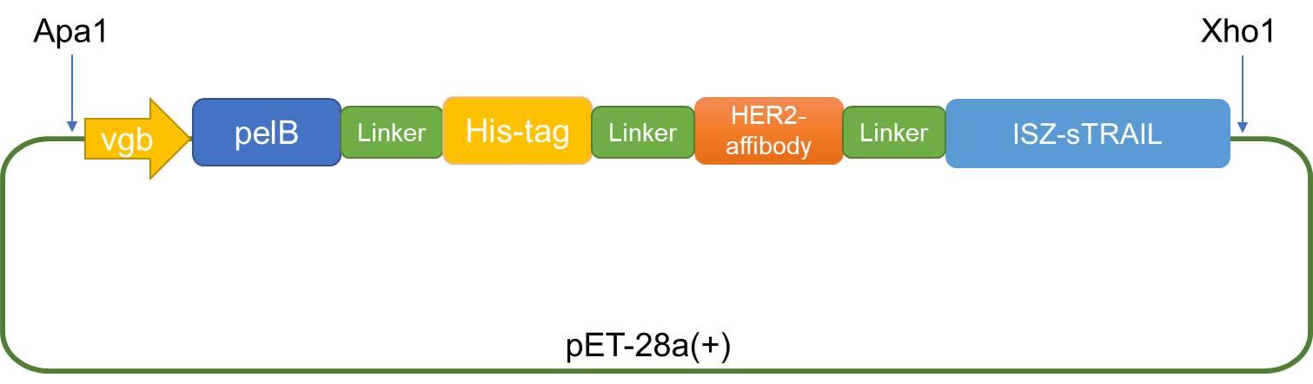

Fig.1 Construction map of Vgb-pelB-linker-His-linker-Her2-linker-ISZ-Strail fusion vector

**1. Construction of Vgb-pelB-Her2-ISZ-sTRAIL expression plasmid**

The sequence of Vgb-pelB-Her2-ISZ-sTRAIL was synthesized and inserted into ApaI and XhoI sites of pET28a(+) expression vectors by company to obtain the hypoxia expression vector -- pET28a(+)-Vgb-pelB-Her2-ISZ-sTRAIL recombinant plasmid (Fig. 2 and Fig. 3).

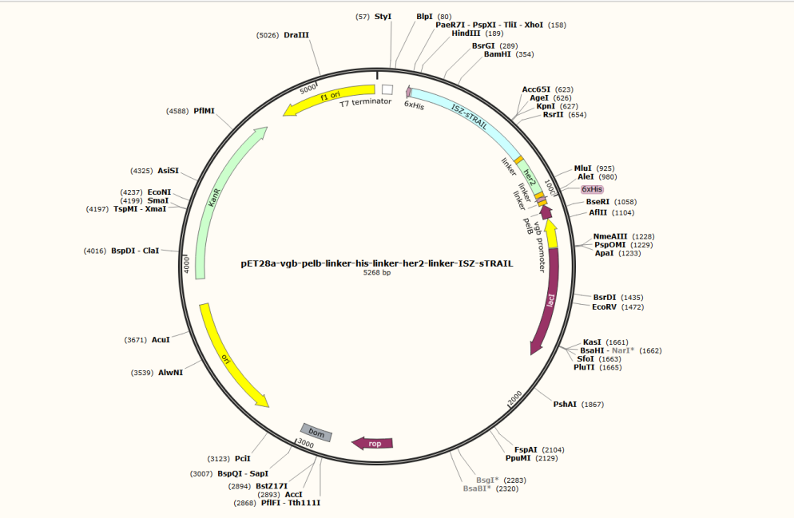

Fig. 2 Map of Vgb-pelB-Her2-ISZ-sTRAIL recombinant vector

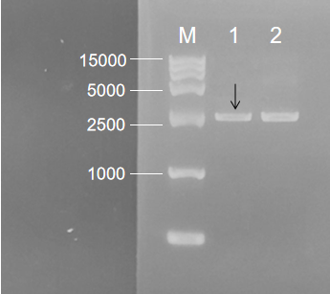

Fig. 3 Agarose gel electrophoresis of Vgb-pelB-Her2-ISZ-sTRAIL recombinant plasmid. M: DNA Marker; 1: pET-28a- Vgb-pelB-Her2-ISZ-sTRAIL; 2.pET-28a(+)

**2. Construction of an engineered EcN 1917 probiotic strain with Vgb-pelB-Her2-ISZ-sTRAIL**

The Vgb-pelB-Her2-ISZ-sTRAIL plasmid was electrotransformed into EcN 1917, and the positive colonies were screened by patching onto kanamycin LB agar plates. An antitumor engineered strain EcN 1917 (Her2-ISZ-sTRAIL) was successfully obtained (Fig. 4-1). Also the control engineered EcN 1917 (28a) was constructed (Fig. 4-2).

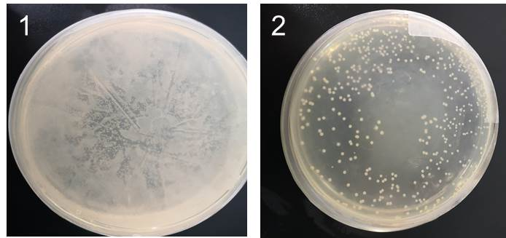

Fig. 4 Results of electroporation of Vgb-pelB-Her2-ISZ-sTRAIL plasmid (1) and pET-28a (+) plasmid (2) into EcN 1917

**3. Her2-ISZ-sTRAIL protein was successfully expressed in tumor-targeting bacteria EcN 1917**

EcN(Her2-ISZ-sTRAIL) and EcN(28a) were cultured in LB medium for 24 h. Then, the proteins in LB medium were concentrated, and subjected to Western blot analysis which was used to confirm the secretory expression of Her2-ISZ-sTRAIL by using Anti-6 × His antibody. It was shown in Fig. 5 that Her2-ISZ-sTRAIL could be efficiently expressed under the control of the hypoxia promoter Vgb and successfully secreted in the medium to exert its anti-tumor activity.

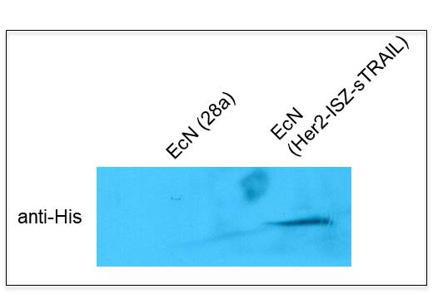

Fig. 5 Western blot analysis of Her2-ISZ-sTRAIL protein expression in EcN (Her2-ISZ-sTRAIL)